Mathematics: Units 2C and 2D
Formula sheet

Number and algebra: Estimation and calculation

For any number a and integers m and n,
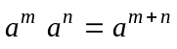
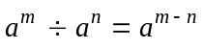

Space and measurement: Measurement

Triangle: Area = × base × height
Parallelogram: Area = base × height
Trapezium: Area = 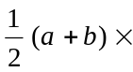height, where a and b are the lengths of the parallel sides

In a right triangle: 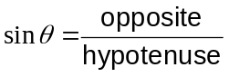 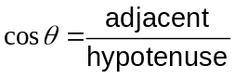 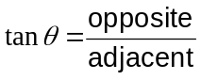

In any triangle ABC,
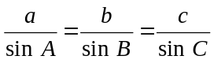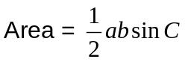

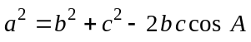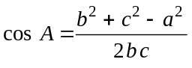

Space and measurement: Coordinate geometry

Gradient of line, m, through the points 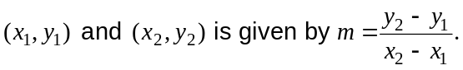

Distance, d, between the points

Lines are perpendicular if 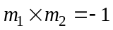

Chance and Data: Quantify chance

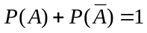

Note: Any additional formulas identified by the examination panel as necessary will be included in the body of the particular question.

